

SIMATS ENGINEERING

Saveetha Institute of Medical and Technical Sciences
Chennai- 602105

Student Name: Shaik Sameer Pasha Reg. No.:192425383
Course Code: ITA0503 Slot: C
Course Name: Computer Vision
Course Faculty: Dr. V R Vimal
Project Title: Multi-Module Vision System Design: Traditional vs. Deep-Learning Approach for Campus Access and Surveillance
Module Photographs: (3 photographs –Module Photo, Individual student contribution module work in the project and presentation image)
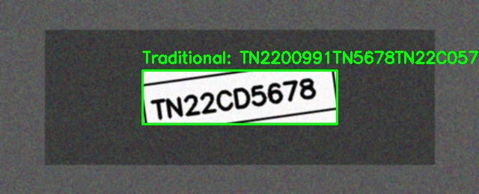
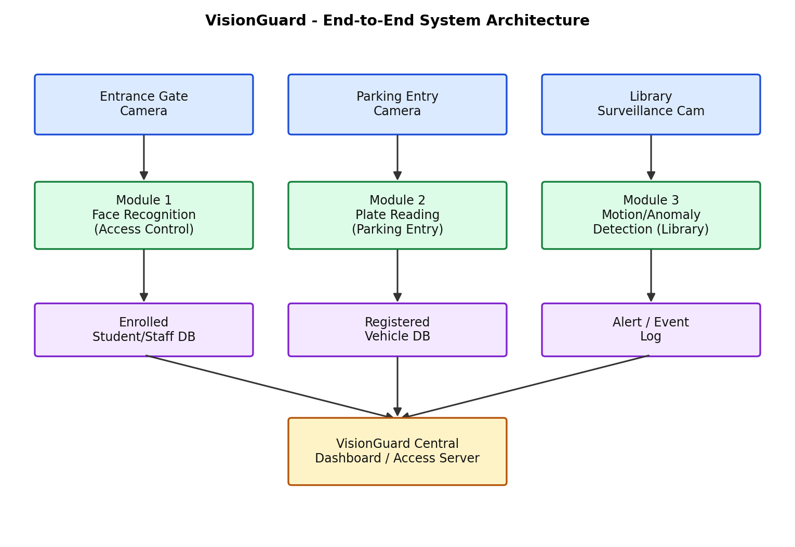
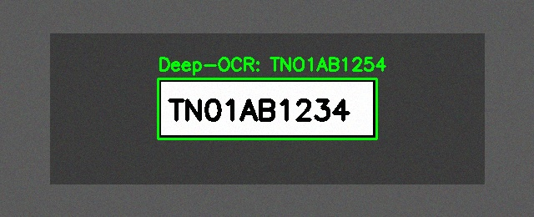
Project Description: (here you write what you did in this project (contribution) including Model Description
Module 2: Vehicle Number Plate Recognition

Module 2: This module analyses vehicles entering the campus parking area and extracts their registration number plates. The input image is converted to grayscale and enhanced using bilateral filtering, followed by Canny edge detection to identify important boundaries. Contours are then analysed based on their geometric properties and aspect ratio to locate the probable plate region. The extracted plate is thresholded and its characters are recognized using OCR. The traditional approach performs explicit character segmentation, while the deep-learning approach can use a plate detector followed by deep OCR to handle skew, blur, glare, and different plate appearances more effectively.

Student Signature Guide Signature

